Arpan Nagar 180905256 CSE B 35
(programs below image)

1 a.

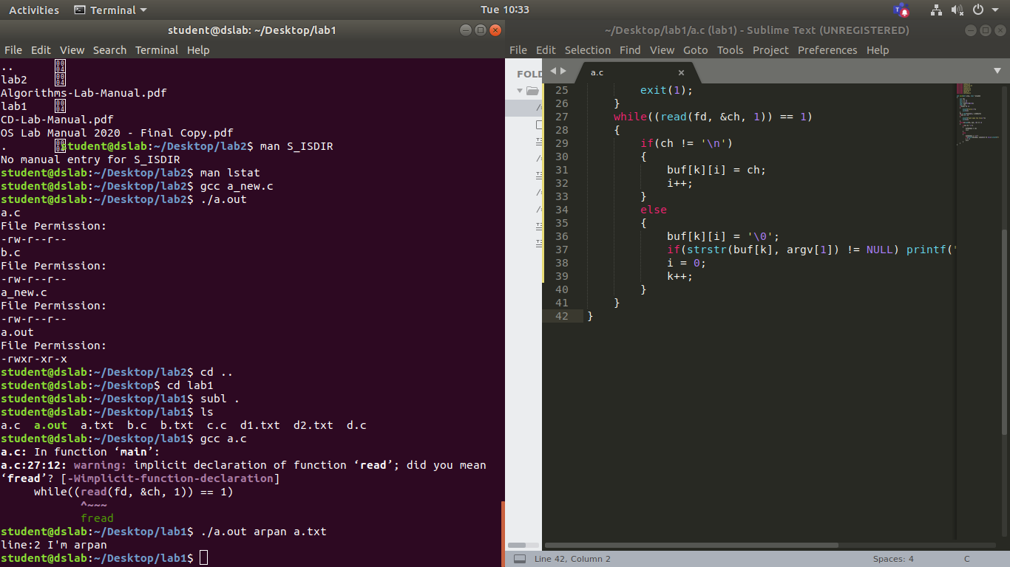
1 b
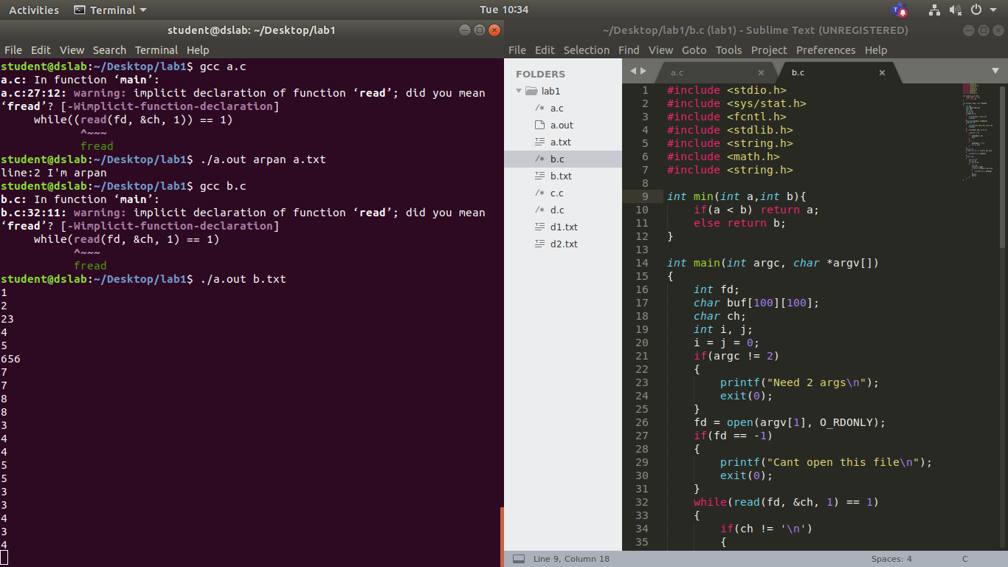

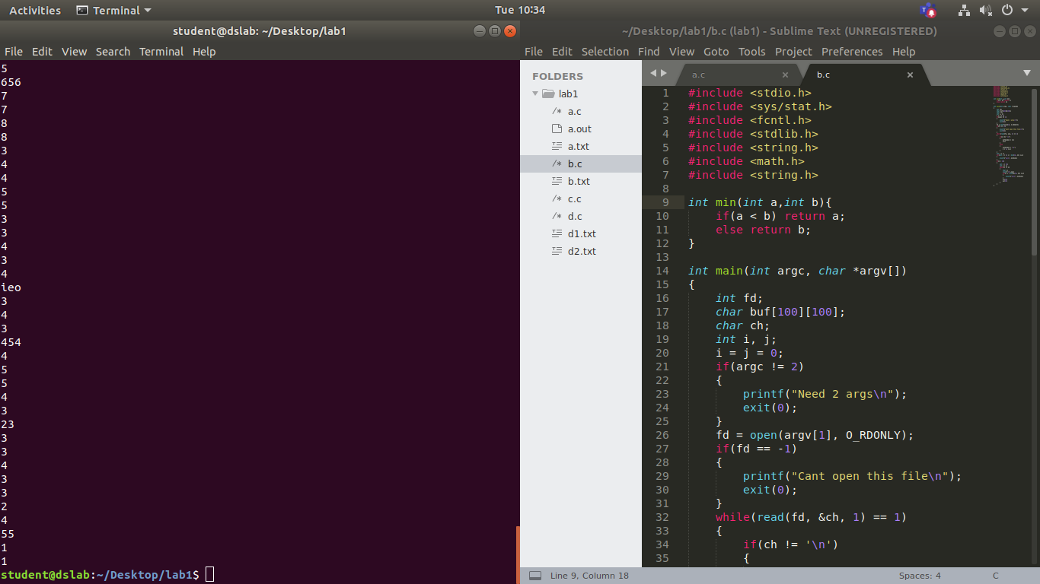
1c
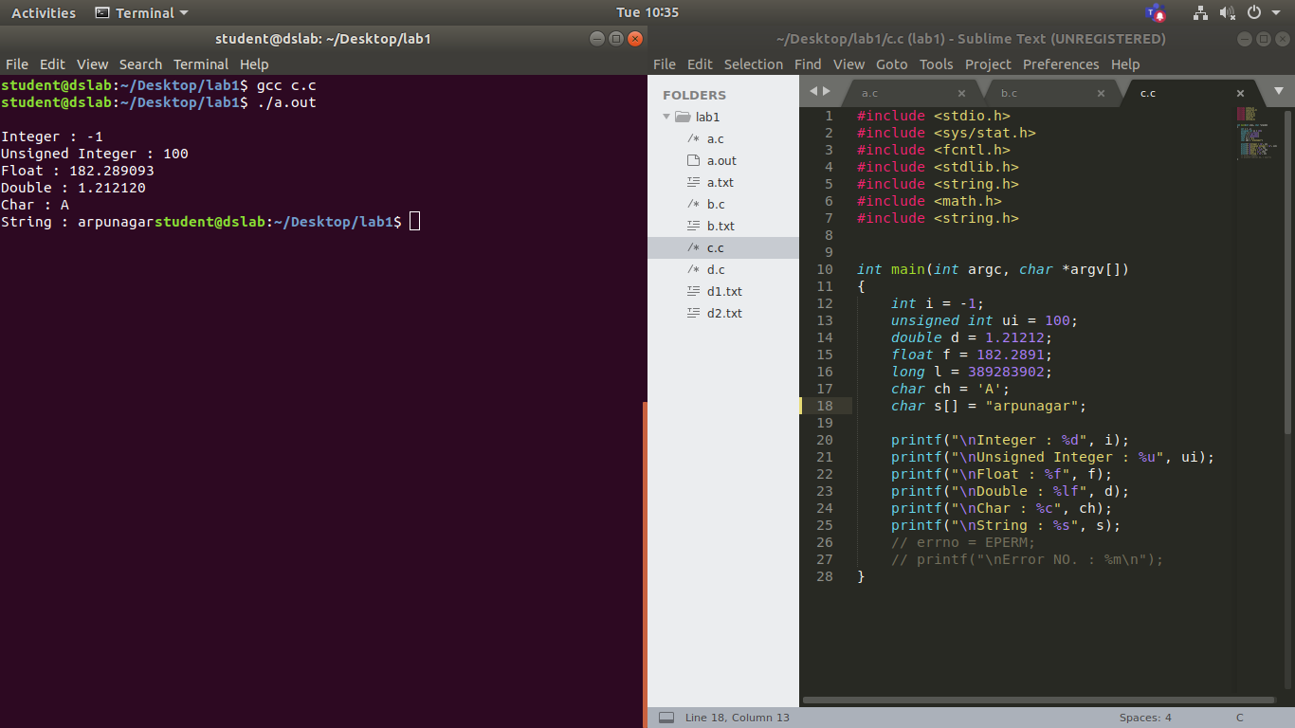

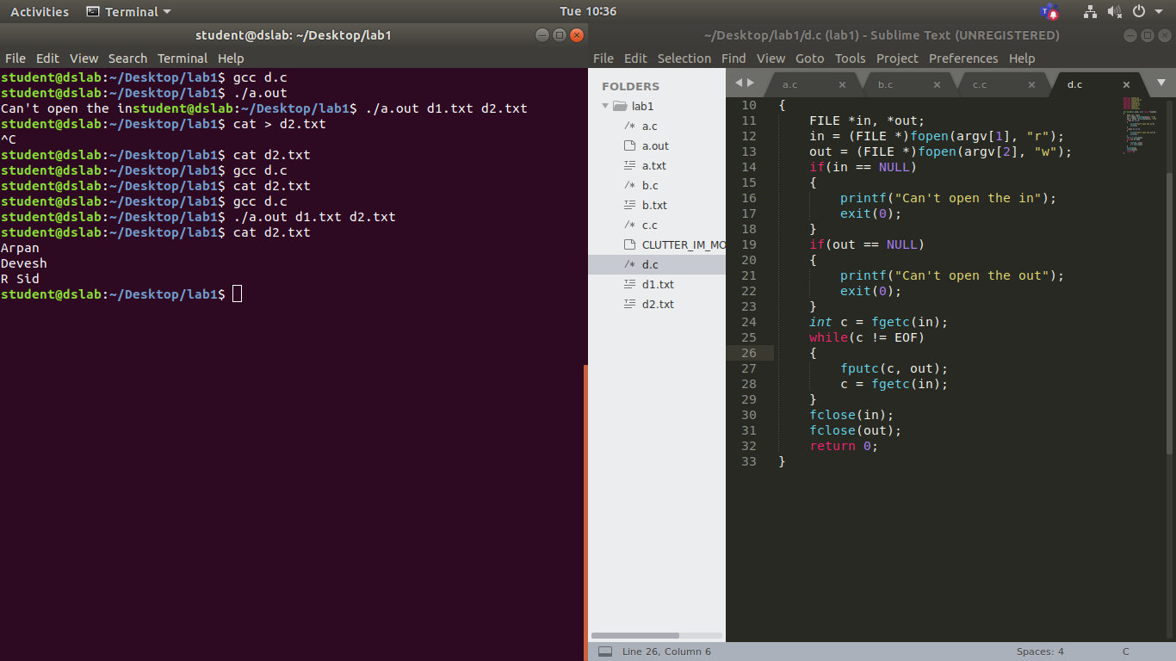
1d

LAB 1

1.

#include <stdio.h>
#include <sys/stat.h>
#include <fcntl.h>
#include <stdlib.h>
#include <string.h>
#include <math.h>
#include <string.h>

int main(int argc, char *argv[])
{
int fd;
int i = 0;
int k = 0;
char buf[100][100];
char ch;
if(argc != 3)
{
printf("error\n");
exit(1);
}
fd = open(argv[2], O_RDONLY);
if(fd == -1)
{
printf("Cant open the file\n");
exit(1);
}
while((read(fd, &ch, 1)) == 1)
{
if(ch != '\n')
{
buf[k][i] = ch;
i++;
}
else
{
buf[k][i] = '\0';
if(strstr(buf[k], argv[1]) != NULL) printf("line:%d %s\n", k + 1, buf[k]);
i = 0;
k++;
}
}
}

2.

#include <stdio.h>
#include <sys/stat.h>
#include <fcntl.h>
#include <stdlib.h>
#include <string.h>
#include <math.h>
#include <string.h>

int min(int a,int b){
if(a < b) return a;
else return b;
}

int main(int argc, char *argv[])
{
int fd;
char buf[100][100];
char ch;
int i, j;
i = j = 0;
if(argc != 2)
{
printf("Need 2 args\n");
exit(0);
}
fd = open(argv[1], O_RDONLY);
if(fd == -1)
{
printf("Cant open this file\n");
exit(0);
}
while(read(fd, &ch, 1) == 1)
{
if(ch != '\n')
{
buf[i][j] = ch;
j++;
}
else
{
buf[i][j] = '\0';
j = 0, i++;
}
}
int k = i;
for(int i = 0; i < min(20, k); i++)
{
printf("%s\n", buf[i]);
}
if(k > 20)
{
int i = 20;
int p = i;
while(i <= k)
{
char x;
scanf("%c",&x);
for(; i < min(p+20, k); i++)
{
printf("%s\n", buf[i]);
}
i+=20;
p+=20;
}
}
}

3.

#include <stdio.h>
#include <sys/stat.h>
#include <fcntl.h>
#include <stdlib.h>
#include <string.h>
#include <math.h>
#include <string.h>

int main(int argc, char *argv[])
{
int i = -1;
unsigned int ui = 100;
double d = 1.21212;
float f = 182.2891;
long l = 389283902;
char ch = 'A';
char s[] = "arpunagar";

printf("\nInteger : %d", i);
printf("\nUnsigned Integer : %u", ui);
printf("\nFloat : %f", f);
printf("\nDouble : %lf", d);
printf("\nChar : %c", ch);
printf("\nString : %s", s);
// errno = EPERM;
// printf("\nError NO. : %m\n");
}

4.

#include <stdio.h>
#include <sys/stat.h>
#include <fcntl.h>
#include <stdlib.h>
#include <string.h>
#include <math.h>
#include <string.h>

int main(int argc, char const *argv[])
{
FILE *in, *out;
in = (FILE *)fopen(argv[1], "r");
out = (FILE *)fopen(argv[2], "w");
if(in == NULL)
{
printf("Can't open the in");
exit(0);
}
if(out == NULL)
{
printf("Can't open the out");
exit(0);
}
int c = fgetc(in);
while(c != EOF)
{
fputc(c, out);
c = fgetc(in);
}
fclose(in);
fclose(out);
return 0;
}

